# **Escape the Zoo!**

# **Game Design Document Outline**

*1. Title Page*

1.1. Game Name – Perhaps also add a subtitle or high concept sentence.

* **Working Title: Escape the Zoo!**

*2. Game Overview*

2.1. Game Concept

* **This game revolves around a monkey escaping the zoo who has to jump from vine to vine until he escapes the city.**

2.2. Genre

* **Side scrolling platformer with a zoo animal theme.**

2.3. Target Audience

* **Our primary target audience will be teenagers and older, but the game will be appropriate for all ages.**

2.4. Game Flow Summary – How does the player move through the game. Both through framing interface and the game itself.

* **The game revolves around tapping the screen at a timed interval to reach the next vine, while avoiding obstacles, poachers, and much more.**

**The player will be able to move in one direction, jump, and swing from vines. The jumping movement will be accessed by tapping the screen. Vine swinging will occur only if the player taps the screen at the appropriate time. Forward movement will be continuous without any user input.**

2.5. Look and Feel – What is the basic look and feel of the game? What is the visual style?

* **Flat design, dynamic visuals, bright foreground of player and platforms with duller background.**

*3. Gameplay and Mechanics*

3.1. Gameplay

* **Very little controls from user needed. Simple tab and swipe action from user. Tab to Jump. Swipe to swing/run. Press ‘n hold to activate “special ability.”**

**Special ability can come from -- Acquired items, upgrade, etc.**

3.1.1. Game Progression

* **Each level is staged - not procedurally generated, and gets progressively harder as the player goes through the levels**

3.1.2. Mission/challenge Structure

* **Main mission - Escape the zoo, without capture from the zoo-keepers, dog catchers, etc.**
* **Players can choose and complete individual characters route, can later use collected characters for other modes.**

3.1.3. Puzzle Structure

* **Not relevant to our game at this time.**

3.1.4. Objectives – What are the objectives of the game?

* **To avoid capture and escape the city. Our unit (character) avoid various obstacles and find a route to the finish point within a certain time. ~(Maybe implement a clock-based timer where we will have to obtain extra time from each check point -- similar to what is used in many arcade based racing games; such as Initial D, Detona, etc.)**

3.1.5. Play Flow – How does the game flow for the game player

* **The game progressively speeds up and throws more obstacles, making the game more and more challenging.**
* **There is only one life per game, so the game abruptly ends when the player dies and must start a new game.**

3.2. Mechanics – What are the rules to the game, both implicit and explicit. This is the model of the universe that the game works under. Think of it as a simulation of a world, how do all the pieces interact? This actually can be a very large section.

* **The mechanics revolve around simple timed touch presses. The user must tap the screen when the monkey should release and reach for the next vine. The monkey automatically grabs the next vine, if the user times the arc correctly. This all must be done while also considering avoiding obstacles and enemies.**
* **The player can run into power ups that boost different attributes such as speed or health.**

3.2.1. Physics – How does the physical universe work?

* **The physics of the game universe will be similar to real world physics. Gravity will be the most important factor.**

3.2.2. Movement in the game

* Always left to right - no traveling backwards, automatically move forward at a moderate set speed, jumping controlled by tapping the screen. Monkey will travel by swinging from vine to vine and occasionally by walking.

3.2.3. Objects – how to pick them up and move them

* Running through an object (such as food or another type of power up) automatically picks it up and uses it. The player won’t carry any objects.

3.2.4. Actions, including whatever switches and buttons are used, interacting with objects, and what means of communication are used

* Actions
  + Jump - double tap
  + Grab vine - tap near the vine to be grabbed
  + Let go of vine - tap near the vine to be released
* Interactions with objects
  + Power ups - run through the location where the power up is, gain buffs
  + Finish - run through the “finish line” which would be the edge of the city/start of the wilderness

3.2.5. Combat – If there is combat or even conflict, how is this specifically modeled?

* There is no combat, just a conflict between the monkey and the zookeeper

3.2.6. Economy – What is the economy of the game? How does it work?

* You accumulate points as you go to spend them on different upgrades.

3.2.7. Screenflow -- A graphical description of how each screen is related to every other and a description of the purpose of each screen.

3.3. Game Options – What are the options and how do they affect gameplay and mechanics?

1. Regular play - regular staged story mode. -- game is story driven and character need to finish multiple stage challenge to win the game.
2. Time Attack - player control unit and try to beat previous record time through each “selected” course for the time attack

3.4. Replaying and Saving

* Player story/staged based mode automatically save record and unhides unlocked stages.

3.5. Cheats and Easter Eggs

* **None planned at this time. --Extra Stage -- Harambe Mode Perhaps?**

*4. Story, Setting and Character*

4.1. Story and Narrative – Includes backstory, plot elements, game progression, and cut scenes. Cut scenes descriptions include the actors, the setting, and the storyboard or script.

* **Our main character is a young monkey who was taken into captivity recently. The entire point of the game is to help this monkey escape the zoo and return to his family.**
  + **This will be conveyed through a small cut-scene before the gameplay begins.**
    - **Actors: zoo keeper, the monkey - main character, various background monkeys - wilderness.**
    - **Scene 1: monkey is shown in the wilderness with monkey friends, zoo keeper sneaks up on him, and he gets captured**
    - **Scene 2: monkey wakes up alone in zoo cage**
    - **Scene 3: giraffe pilfers keys from the zoo keeper and tosses them into the monkey’s cage, monkey opens his cage door, and (after a short pause) the level begins!**

4.2. Game World

* 1st stage

4.2.1. General look and feel of world

* 1st/Initial stage -- Zoo to Freedom -- Our main character goes escape from its cage to outside freedom
* 2nd stage -- To the Port -- Our main character must sneak into the port into ship/airplane in order to leave the city
* 3rd/Final stage -- In the Jungle -- Our main character must avoid Jungle dangers, and poachers to find colony of ally animal creatures

4.2.2. Areas, including the general description and physical characteristics as well as how it relates to the rest of the world (what levels use it, how it connects to other areas)

* Monkey’s cage: only is seen during the initial cutscene to show the escape
* Zoo: The first stage in the quest for escape. Gameplay happens here.
  + Other animal exhibits, the zoo keeper, and the environment (like a flamingo pond) pose challenges to escaping the zoo. The zoo has lots of trees with vines to swing from.
* City: typical city with skyscrapers, pedestrians, and sidewalks.
  + The zoo keeper, construction, open manholes in the ground are examples of obstructions the monkey will have to avoid.
  + More of a platformer stage
* Port: has docks and large ship with shipping containers
  + Monkey finds a shipping container with bananas and hides in it
  + Once you reach the port it goes to a cutscene of him finding the container, and getting in
* Wilderness: Jungle area with lots of trees and other animals in the background
  + Initially will just be a place with a nice monkey-reunion cutscene, but it presents an opportunity to eventually expand into a procedurally generated stage of levels where another zoo keeper has come, and you swing through the jungle avoiding recapture.

4.3. Characters. Each character should include the backstory, personality, appearance, animations, abilities, relevance to the story and relationship to other characters

* **Main character: monkey.**
* **Supporting cast: Zookeepers, other animals. The zookeepers will be the main antagonist. Their role is to capture our main character, thus resulting in a game over if captured.**

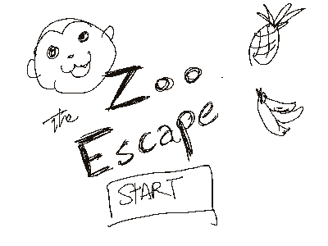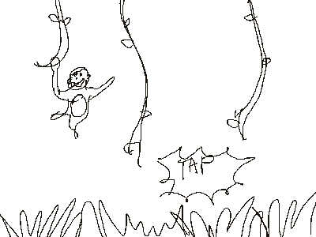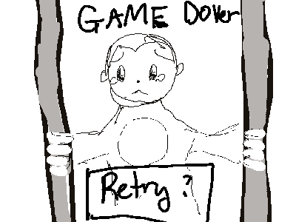

*5. Levels*

5.1. Levels. Each level should include a synopsis, the required introductory material (and how it is provided), the objectives, and the details of what happens in the level. Depending on the game, this may include the physical description of the map, the critical path that the player needs to take, and what encounters are important or incidental.

* Minimum Number of Levels: 1
* Level 1:
* Stage 1: escaping the zoo grounds
  + Objective: get out of the zoo and enter the city
  + What happens: you (the monkey) leave the cage and automatically start out running. 2 seconds in the zoo keeper notices and starts chasing. The path is predetermined (like temple run).
* Stage 2: escaping the city
  + Objective: get out of the city and to the port
  + What happens: you cross into the city and there is a change of scenery. The zoo keeper still chases you, and now so does animal control (basically a second zoo keeper). Path is predetermined along sidewalks and maybe through an office building.
* Stage 3: reaching the port and jungle
  + For now, it’s all cutscenes from here.

5.2. Training Level

* **Level one will be simple enough to act as a tutorial for the player.**

*6. Interface*

6.1. Visual System. If you have a HUD, what is on it? What menus are you displaying? What is the camera model?

* Heads-Up-Display:
  + Number of lives the character have. --start with 3X lives
  + Health Points (HP) -- Character can get damage to HP by falling, obstacles, poison, etc.
  + Currencies: Banana -- Collectable Items in the game - usage to-be-decided
* Camera Model -- Camera will follow our character as it scrolls from left to right. Character and Camera are centered, except at start and end of each stage

6.2. Control System – How does the game player control the game? What are the specific commands?

* **The only input expected of the user is to tap the screen to jump and swing on vines.**

6.3. Audio, music, sound effects

* **Chien can make sounds, royalty free/ public domain/ self compose BGM, Sounds effects can be collected through own recording, from objects, outside, etc.**
* Falling sound, jumping sound, power-up sound, injury sound, defeating an enemy, game over sound, background music, generic zoo sounds (monkeys, birds).

6.4. Help System

* A written instruction page that can be accessed at any time by pausing the game.

*7. Artificial Intelligence*

7.1. Opponent and Enemy AI – The active opponent that plays against the game player and therefore requires strategic decision making

* **Zookeepers will be chasing the player from behind but will only catch up if the player hits a wall. Poachers will not be seen but their bullets will be telegraphed with some sort of visual indicator, which should allow the player to adjust appropriately to avoid them.**

7.2. Non-combat and Friendly Characters

* **All non-combat and friendly characters will interact only in a visual format as art Assets to enhance the user experience.**

7.3. Support AI -- Player and Collision Detection, Pathfinding

* **The monkey should interact with the ground and air in a fashion that one would expect under the effects of gravity. If the player falls into a space that isn’t**

**occupied by ground, that should result in a game over or loss of life.**

* + Primary enemy - Present in tier 2 and 3, Zookeeper, chases from behind at a varying speed, occasionally drops from above
  + Secondary enemies - Present in tier 3 poachers, other animals (lion, tiger, bear)- same AI as zookeeper

8. Technical

8.1. Target Hardware

* **Ios & Android.**

8.2. Development hardware and software, including Game Engine

* **Unity will be the game engine we use.**

8.3. Network requirements

* **Data connection to load ads and keep track of highscores.**

9. Game Art – Key assets, how they are being developed. Intended style.

* Asset Development Platforms: Illustrator and Photoshop
* Intended Style: cartoon flat design, like:

10. Inspiration 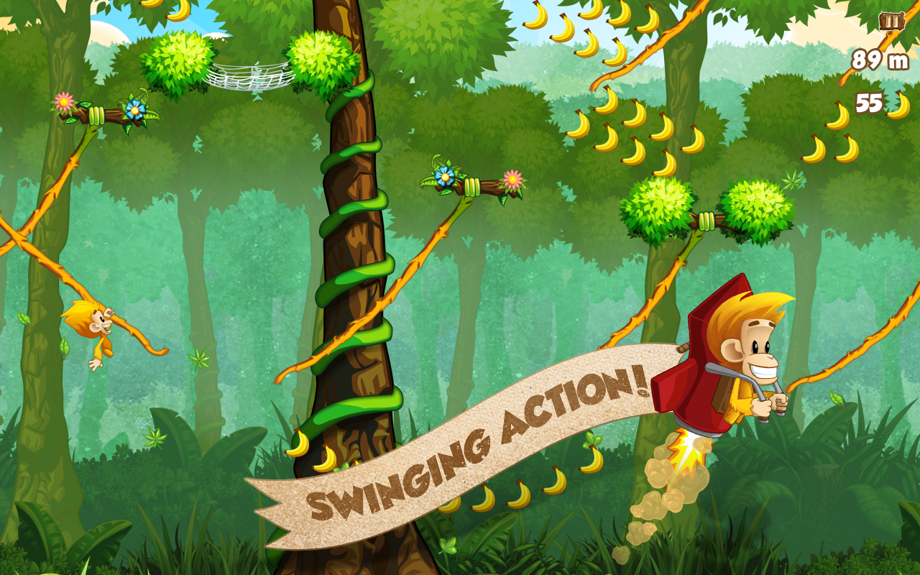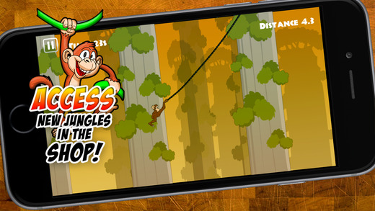

11.Goals/WishList

* 3-5 levels with boss levels. Boss maybe be poacher following and shooting at monkey.
* AI enemies scattered throughout game to throw monkey off vines.
* Smart sidekick AI to deter enemies.